T shapes
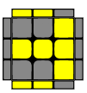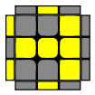
(Sexy Move) R' F R F ' F (Sexy Move) F'
L shapes
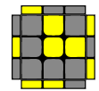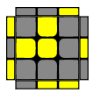
F' [(L' U' L U) X 2] F F [(Sexy Move) X 2] F'
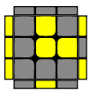
Fat sune x 2
La vediamo nel lighting shapes 2
P shapes
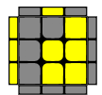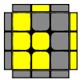
f (Sexy Move) f' f'(L' U' L U) f
Fish Shapes
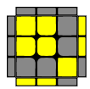
F R (U' R' U') (R U R') F'
Uguale ad algoritmo in diagonale per aggiustare angoli

Lighting Shapes
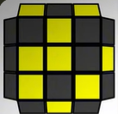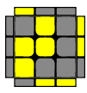
(Sune) + T Shape 2 r (U R' U R) U2 r'
Sune + F (Sexy Move) F' fat sune

